1. 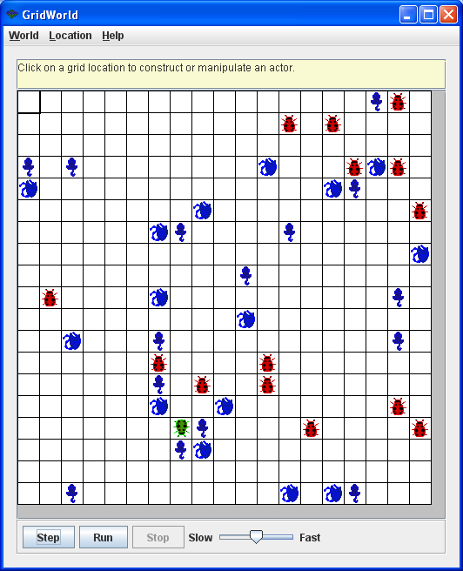Given the ActorClient that I wrote, find the Actor in the Grid that has the most neighbors adjacent to it. Change its color to green, and make it face south as in the picture. If there are multiple Actors that meet this criteria, choose any one of them, change its color to Green, and make it face south.

Work with the **grid** object that I created in the code. Use the API reference in the pink book – pages B1-B4. Only make changes to the client where indicated by the comments. There’s no need to press “start” or “step” on the GUI to test it.

1. 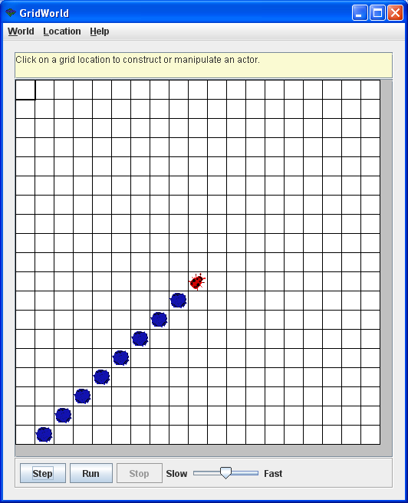The BugClient I wrote has a single Bug in it referred to by **b**.Add blue rocks to every location behind the Bug, all the way up to the edge of the grid. You will need to loop to accomplish this, and a ‘while’ will generally work better than a ‘for’ because you won’t know how many times to loop until you hit the wall. It should handle the extreme case where there are no empty Locations behind the Bug (i.e. when the bug is sitting up against the wall). It should not cause a runtime exception in this case.

Work with the **grid** and **b** objects that I created in the code. Use the API reference in the pink book – pages B1-B4. Only make changes to the client where indicated by the comments. There’s no need to press “start” or “step” on the GUI to test it.